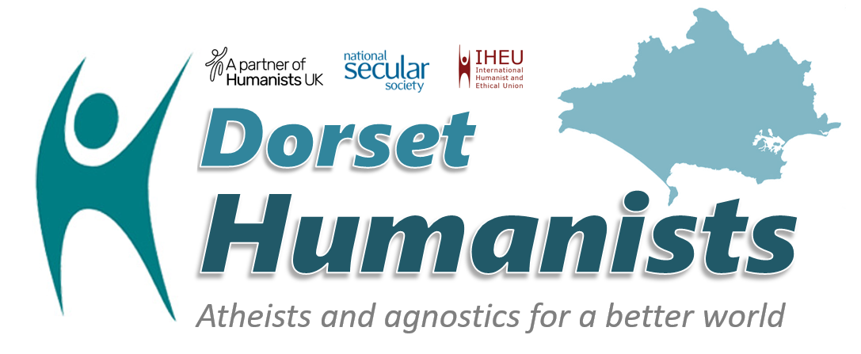
Why join Dorset Humanists?
Members provide the core funding for our activities – thank you!
Discounts on special events for members
Numbers matter to politicians if we wish to influence public policy – can we count you in?

Joining form

Name(s):
Address:
Phone/mobile:
Email:
Please see our Data Protection policy overleaf

Please tick option(s) which apply:
❒ £15.00 Full membership for one year
❒ £7.50 Addition for family member/partner at same address
❒ £5.00 Student rate or unwaged/low income
Please tick your preferred payment method and return the completed form to David Warden, 58a R L Stevenson Avenue, Bournemouth BH4 8EG or email to secretary@dorset.humanist.org.uk or chairman@dorset.humanist.org.uk
❒ Direct Debit which helps reduce our administration: Please visit our website https://dorset.humanist.org.uk/ click Get Involved/Join and follow the simple process. Our service provider GoCardless is an FCA Authorised Payment Institution ref no. 597190. Dorset Humanists does not hold your bank details.
❒ BACS: Please ask for our bank details if you prefer to make a direct payment.

■ Declaration: I/we support the aims of Dorset Humanists and give permission for you to record my data as provided above (see more details overleaf)
Signature(s): Date:

I wish this subscription/donation and all subsequent subscriptions/ donations I may make in the future to Dorset Humanists to be treated as gift aided. I confirm that I am a UK tax payer and will notify you if this changes.
Signature(s): Date:
By completing the gift aid declaration we will be able to claim back basic rate income tax on this and all subsequent subscriptions and/or donations that you make to Dorset Humanists. Dorset Humanists is recognised as a charity by the Inland Revenue. HMRC Charities Ref No EW10227.

Office use

Membership database updated ❒

Email database updated ❒

Acknowledgement sent ❒

Data Protection
- Dorset Humanists is required to comply with the General Data Protection Regulations 2018. In accordance with these Regulations we are obliged to provide you with the following information about your personal data which Dorset Humanists holds, which includes some or all of your full name, your postal address, your e-mail address, and your telephone number:
- The name and contact details of our organization is Dorset Humanists. Our contact details are provided below.
- The purposes of Dorset Humanists holding your personal data is to be able to send notices of our meetings and our monthly bulletin to our members and supporters.
- The lawful basis for the holding this information is that it is in the legitimate interests of Dorset Humanists to be able to communicate with its members by e-mail, post and telephone.
- Your personal data will be retained indefinitely even if you cease to be a member of Dorset Humanists unless you instruct us to destroy your personal data.
- If you have any concerns regarding how Dorset Humanists is handling your personal data you have the right to lodge a complaint with our supervisory authority, which is the Information Commissioners Office, Wycliffe House, Water Lane, Wilmslow, Cheshire, SK9 5AF. Tel: 0303 123 1113

Child safeguarding
We have a child safeguarding policy agreement with our Partner, Humanists UK. You can ask for a copy.
Equality and non-discrimination
Dorset Humanists is committed to ensuring that no member or visitor will experience prejudice, hostility, or stereotyping on the grounds of class, educational background, race, ethnicity, nationality, sex, gender, age, religion, political opinions, disability, neurodiversity, sexual orientation, gender reassignment, or criminal background. We welcome people of all beliefs to our events except beliefs which violate this policy. Membership implies support for our aims which are stated below:

Our 5 aims
- To promote Humanism understood as a non-religious ethical worldview
- To develop, and serve the needs of, the humanist community in Dorset
- To promote the public understanding of science
- To be a force for good in our local community and globally
- To support the work of our partners (Humanists UK and National Secular Society)

Contact
🕿 David Warden 07910 886629
🖳 chairman@dorsethumanists.co.uk
🖂 Registered postal address: Dorset Humanists c/o Humanists UK, 39 Moreland Street, London EC1V 8BB

